At the end of 2011, there was $1.39 billion left in TIF bank accounts...
...yet the City claimed a budget deficit of $636 million at the start of 2012.


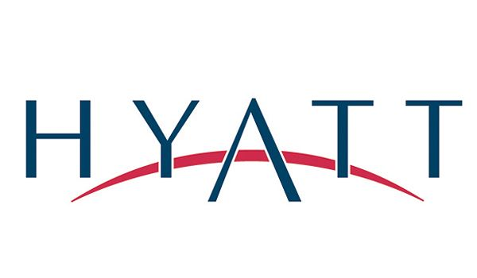

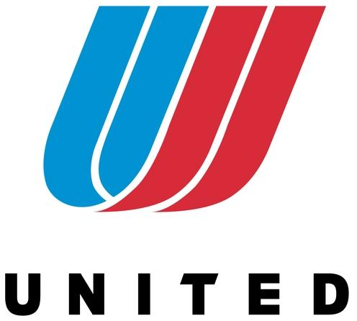
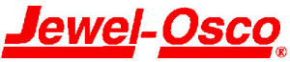
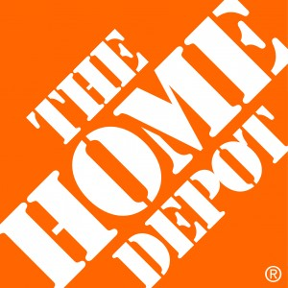



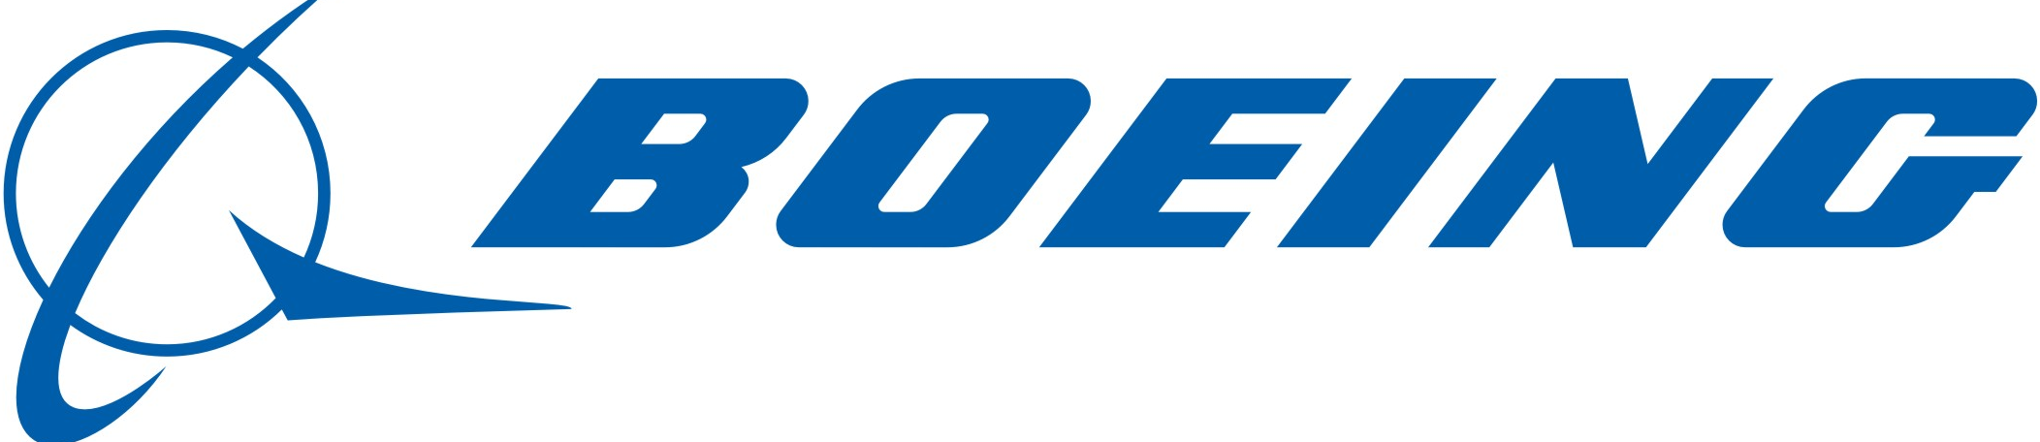
Our Taxes…Who Profits?

In Chicago, of the $4.5 billion extracted since TIFs began,
55% have gone to private projects.

Meanwhile our schools, parks, libraries and clinics are starved of resources and closed by the City--even as we pay more in property taxes and rent.

Be part of the solution at the
TIF Town Meeting.
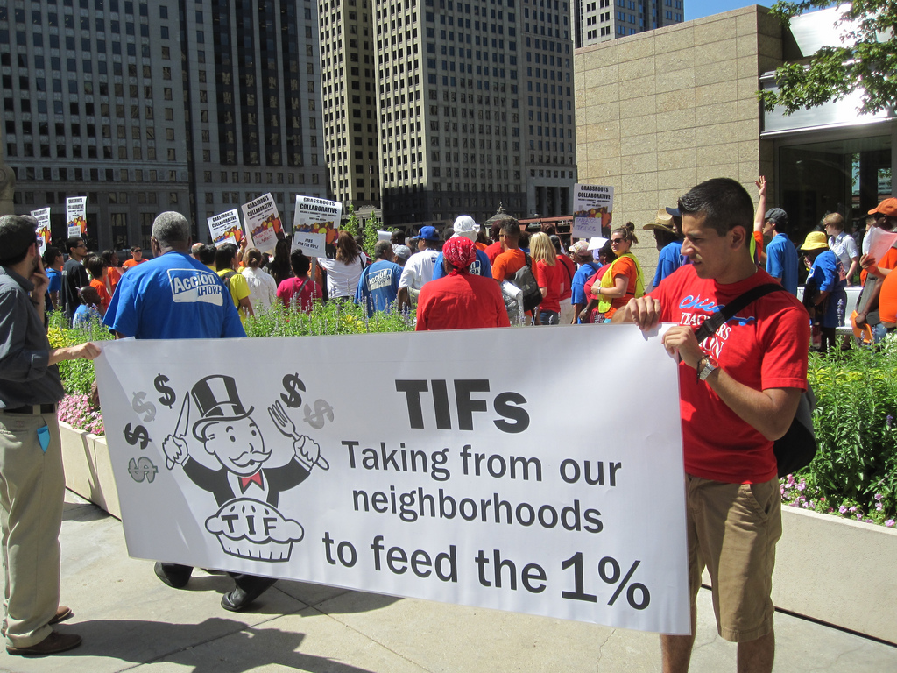
Tuesday, February 12, from 7-9 pm
at the Chopin Theatre, 1543 West Division
(just west of the Blue Line stop)

Featured Speakers: Ben Joravsky - Award winning political reporter.
Tom Tresser - Citizen activist and civic educator.
Dr. Richard Dye - Professor at UIC Institute of Government + Public Affairs.

Featured Breakout Groups: Become a TIF Illuminator; Design Your Own Utopia (participatory budgeting); Grassroots Organizing.

Sponsored by The Tax Integrity and Fairness Alliance, an open group dedicated to exposing and changing TIFs as part of bringing public control over our taxes and the budget.
http://TIFAlliance.weebly.com - TIFAlliance@gmail.com
Endorsed by: * Chicago Gray Panthers * Chicago Teachers Solidarity Campaign * CivicLab *
* Pilsen Alliance * Progressive Democrats of America-IL * Illinois PIRG *

